004 Gulp - series & parallel

Gulp Kata List – Blog Page

[TypeScript Kata List on GitHub](https://github.com/robertdunaway/katas-typescript)

# Duration

5 minutes

# Brief

Using the existing gulpfile.js add three new tasks.

### For More Information

BING/GOOGLE: “Gulp series parallel”

Book: <http://www.amazon.com/Gulp-Quick-guide-getting-running/dp/151468960X>

# Instructions

Get tutorial folder or the entire katas-angular2 repo.

Open the [before/*.sln] file and execute the kata.

Feel free to execute this kata multiple times because repetition creates motor memory.

# Github

* Before (start kata with this)
  + https://github.com/robertdunaway/katas-gulp/tree/master/003%20Gulp%20-%20multiple%20tasks%20%26%20vs/before
* After
  + https://github.com/robertdunaway/katas-gulp/tree/master/003%20Gulp%20-%20multiple%20tasks%20%26%20vs/after

# Kata

Using the existing gulpfile.js create three new functions named “task1”, “task2” and “task3” and then execute them as part of the default task.

# Review

The task could look like the following.

gulp.task('task1', function () {

console.log('my first gulp task…');

});

gulp.task('task2', function () {

console.log('my second gulp task…');

});

gulp.task('default', function () {

console.log('my third gulp task…');

});

Adding these task to the default task.

gulp.task('default', ['task1', 'task2', 'task3']);

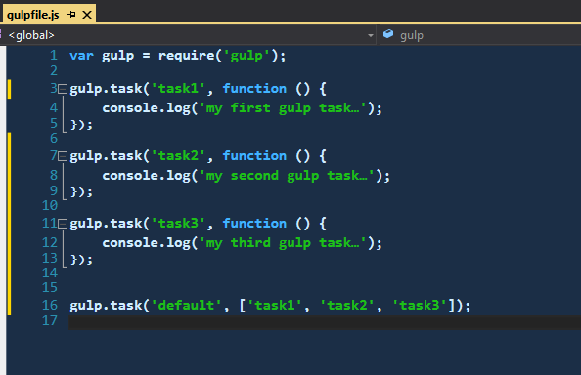

Now execute the default task.

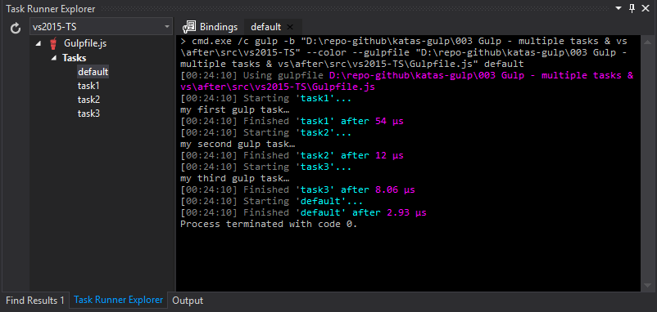

# Next

Take a few minutes and imagine more examples.